1. Features

* A single login page for both portals.
* Receptionists can register a new patient & perform CRUD operations.
* Doctors can view registered patients & view graph that represent the number of patients registered vs days.
* Interactive and self explanatory UI (dashboard)
* Used authentication
* Separate views/layout for two different users (doctor / receptionist)
* Separate controller (doctor and receptionist) inherited from a base controller

1. Screenshots of working system

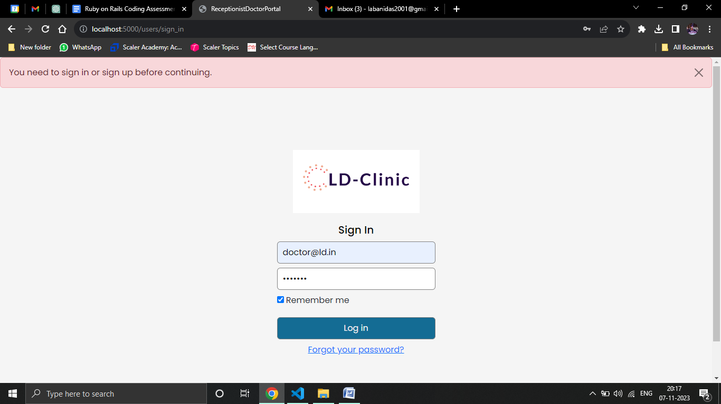

Common login screen

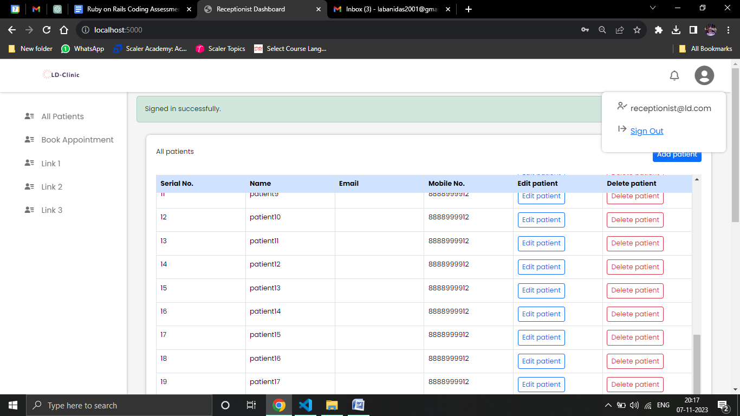

See all patients

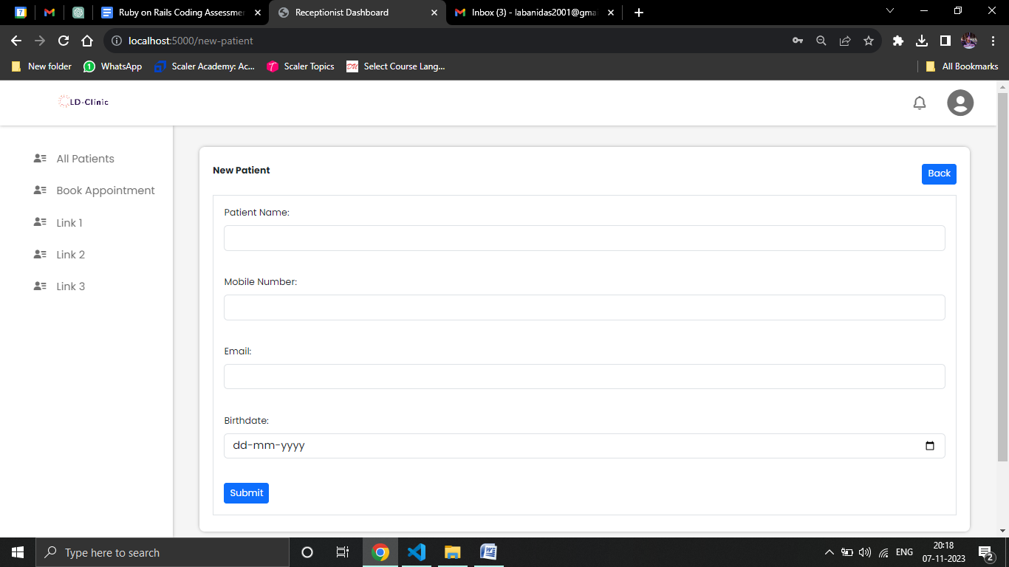

Create a new record

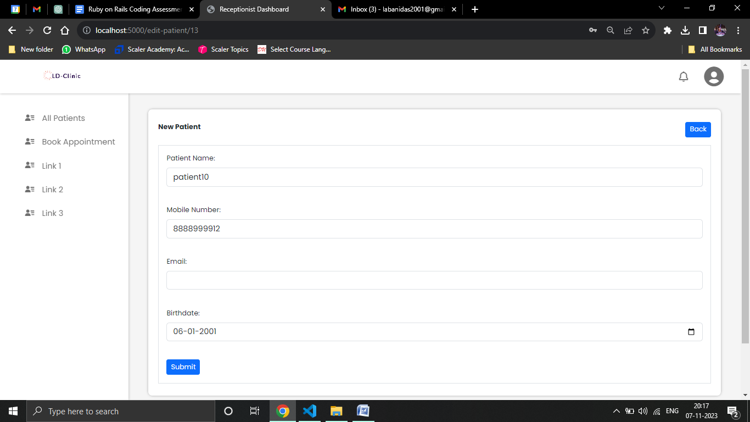

Update existing one

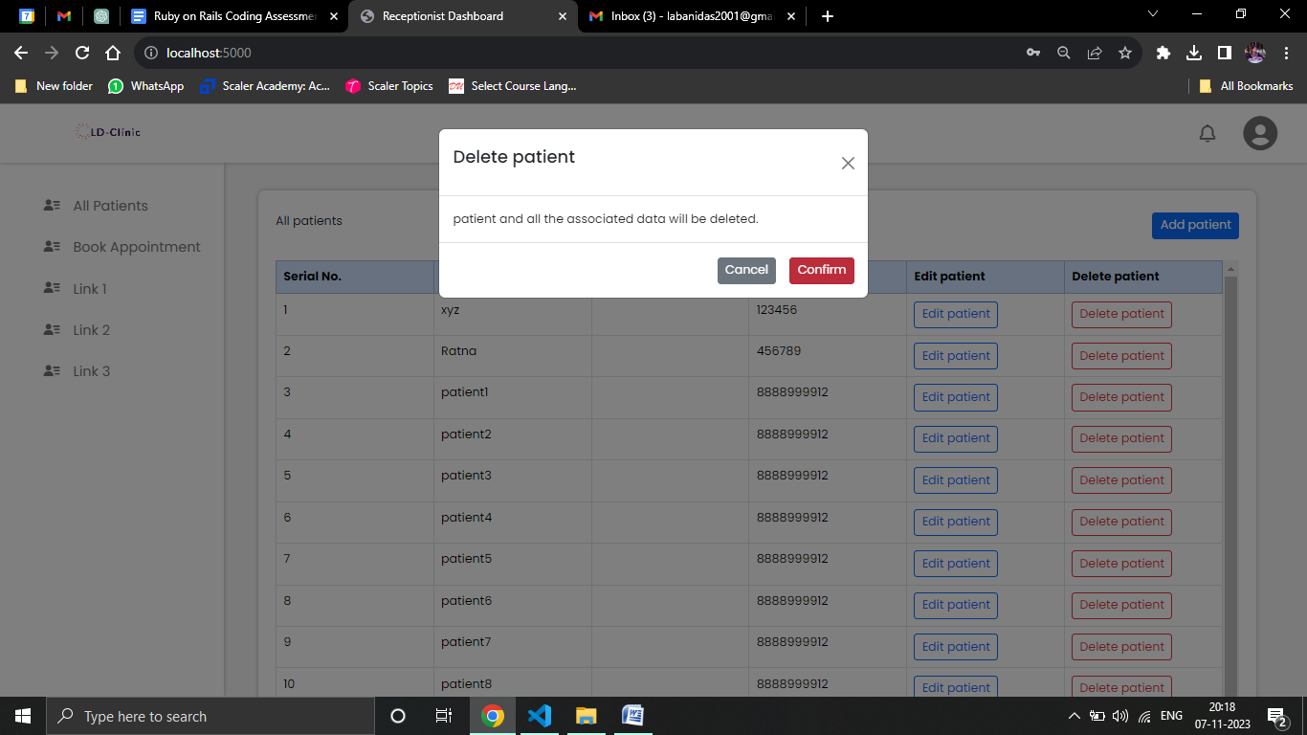

Can delete. Modal window appears for confirmation.

Receptionist can see, create, update and delete patient (details).

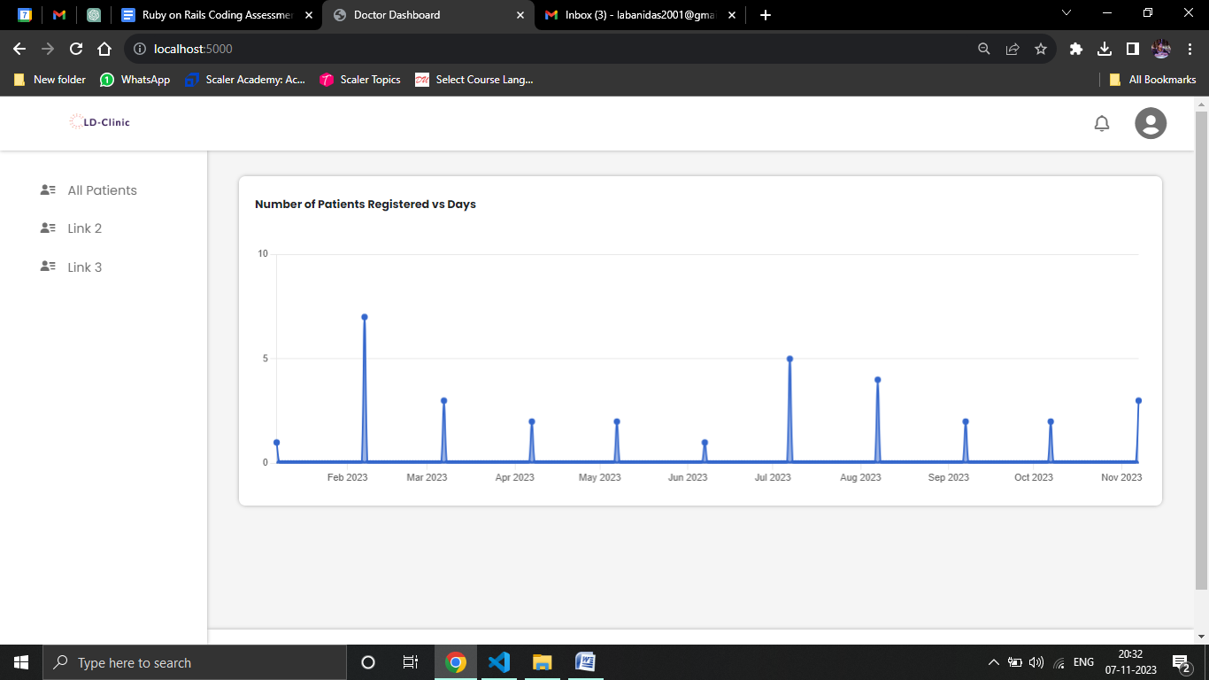

Doctors can see graph that represents number of patients registered vs days.

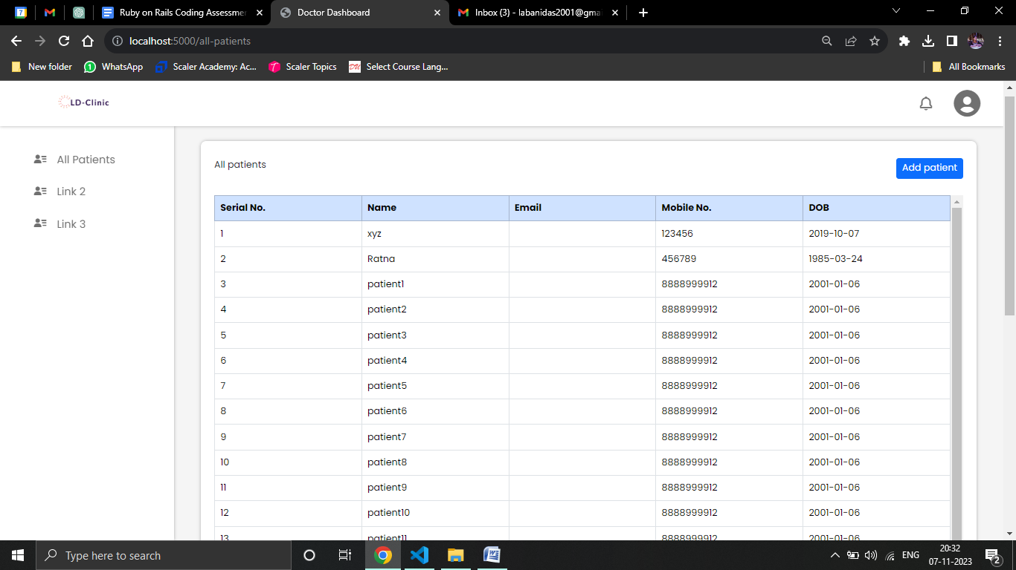

Doctors can view registered patients.

1. Gems used
2. gem 'pg' // for using postgresql
3. gem 'devise' // for authentication system
4. gem 'bootstrap' // for UI/UX
5. gem 'jquery-rails' //for UI/UX
6. gem 'pry' //for debugging
7. gem 'chartkick' // for displaying chart
8. gem 'chartjs-ror'
9. gem 'groupdate' // for displaying chart
10. Controllers
    1. Base 🡪 the base controller
    2. Receptionist 🡪 inherited from base controller, used specifically for receptionist
    3. Doctor 🡪 inherited from base controller, used specifically for doctor
11. Necessary partials and views
    1. The modal window used for comfirmation before deleting
    2. The sidebar
    3. The floating profile-options (sign out), that appears and dissapears
    4. **Use of Separate layout for doctor and receptionist**
12. Steps to setup
    1. **Download zipped**
    2. **Cd ‘folder-name’**
    3. **create database in postgreSQL** 
       1. <https://youtu.be/-ajUunAwezo?si=Ah4vpnHD_OffiafA>
    4. **Bundle**
    5. **Rails db:migrate**
    6. **Rails db:seed**
    7. **Rails s**

Go to **seed.rb** file (ctrl+p to search in vscode), copy the email id, password of **user** and login as doctor or receptionist.

1. Tools used
   1. <https://www.shopify.com/tools/logo-maker/my-logos> for making logo